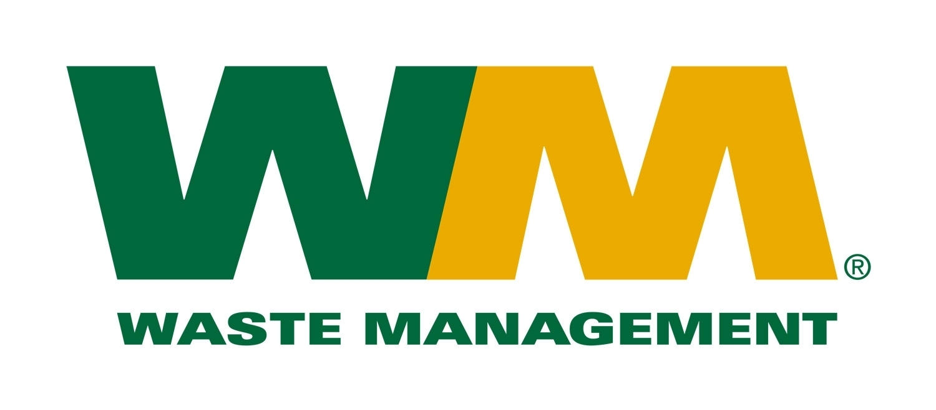
TOWN OF EDEN NY
RECYCLING AND REFUSE GUIDELINES

Town of Eden 96 Gallon wheeled totes will be used for both the collection of trash and recycling. Each tote has a serial number on it, which matches it to the address it will be delivered to. If a resident would like an additional 96 Gallon trash tote, or an additional 96 Gallon recycle tote, it may be purchased through the town, and used for your regular service. An additional tote can be purchased at the Town Clerk’s Office.

Service Day
All households in the Town will have their garbage serviced weekly. However, recycling will be serviced every other week. If your garbage or recycling does not get picked please call the Supervisor’s Office at 992-3408 opt. #1.

Garbage Set-out Limits
All refuse (trash bags, general trash), must be contained inside your new 96 Gallon tote. Garbage must be placed within 2 feet of the street curb by 6:30am of your collection day. All waste must be contained inside the 96 Gallon tote. No trash can be set next to the tote. The trash tote will be picked up with an automated truck with a mechanical arm.

Bulky Waste and White Goods (Appliances)
Waste Management will collect two large items the first full week of each month, which is the first Monday-Friday week of the month. Please see the service calendar for the bulk week schedule. This can be two bulk items or one bulk and one white good (appliance). Bulk waste and white goods will be collected separately (in a separate truck) from your household waste and recycling. Bulk pickup occurs on your service day or the day following your service day. Refrigerators, freezers and air conditioners must have refrigerant (freon) removed by a certified technician and the unit stickered as ‘Freon removed” with the doors removed from refrigerators and freezers.
- Carpeting must be rolled in lengths of 4 feet or less, taped securely, and no wider than 18 inches.
- Large items must be of size that can easily be handled by two employees.
- Additional acceptable items include small furniture, bedding and mattresses (any size), hot water tanks, and large appliances.
- Any item, such as a weed trimmer or small lawnmower, with an engine requiring oil and gas must have those liquids removed prior to collection.

Unacceptable Waste
Dead animals, explosive and flammable materials, pesticides, batteries, compressed gas cylinders, aerosol cans, motor oils, regulated and non-regulated hazardous, pathological, medical, infectious, construction, remodeling, and septic waste, sludge, junk automobiles, recreational vehicles (ATV’s). TIRES ARE NOT ACCEPTED. For more information on disposal of household hazardous waste such as oil and lead based paint, pesticides, antifreeze, etc. contact Erie County Hazardous Waste at 858-6800 or visit www.erie.gov/environment.

Recognized Holidays that Affect Collection
Waste Management observes the following holidays. With the town collection being Tuesday through Friday, Monday Holidays will not affect service. If a Holiday falls on your service day, your collection, and the subsequent week’s collection will be delayed one day.
New Year’s Day Thanksgiving Day Christmas Day

TOWN OF EDEN NY
RECYCLING AND REFUSE GUIDELINES

RECYCLING COLLECTION
- Recycling will be collected on an every other week basis. The attached calendar shows the recycling schedule.

- Recycling will be collected utilizing the Town of Eden branded wheeled totes, which are the property of the Town. These carts may not leave the residence to which they are delivered. Do NOT place recycling in trash bags, the bags can not be recycled.

- The recycling totes will be collected with an automated truck with mechanical arm. Recycling will only be collected in the provided wheel carts. All recycling material must be placed inside the tote, any recycle material that is placed outside the tote will not be collected.

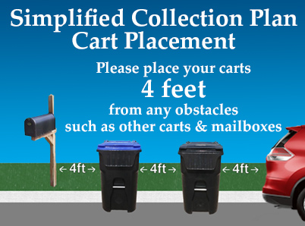
- With automated collection, it will be very important for the resident to follow these set-out guidelines:
- Do not place within 4 feet of the trash tote, your mailbox, or any fixed structure or object.
- Place cart within 2 feet of curb.
- All recyclables must be in the tote.
- Handle of cart should be facing the house, as described on cart lid.

- Acceptable For Recycling:
- Clean cans and bottles, plastic containers, cardboard and paper.
- NO FOOD, LIQUIDS, LEAVES, DEBRIS OR PLASTIC BAGS IN THE RECYCLING.
- See https://www.wm.com/us/en/inside-wm/recycle-right/recycling-101 for more information on recycling items.

